Initial Proof-of-Concept Lab Tests for Capacitance-Based Fluid Detection

Experiment 1: Preliminary Capacitance Response to Moisture
Objective:
To obtain an initial indication that the capacitance value increases as the tampon absorbs more fluid, without aiming for precise measurement or formal documentation.
Methodology:
Two aluminum foil strips with equal surface areas were adhered longitudinally along the tampon to form a basic capacitive structure. The tampon was then gradually wetted with water, and the capacitance was observed using a basic measurement setup.
Results:
The experiment confirmed that the capacitance increased in correlation with the level of moisture in the tampon. Once the reading reached approximately 20 pF, the capacitive plates themselves became wet, at which point the experiment was concluded.
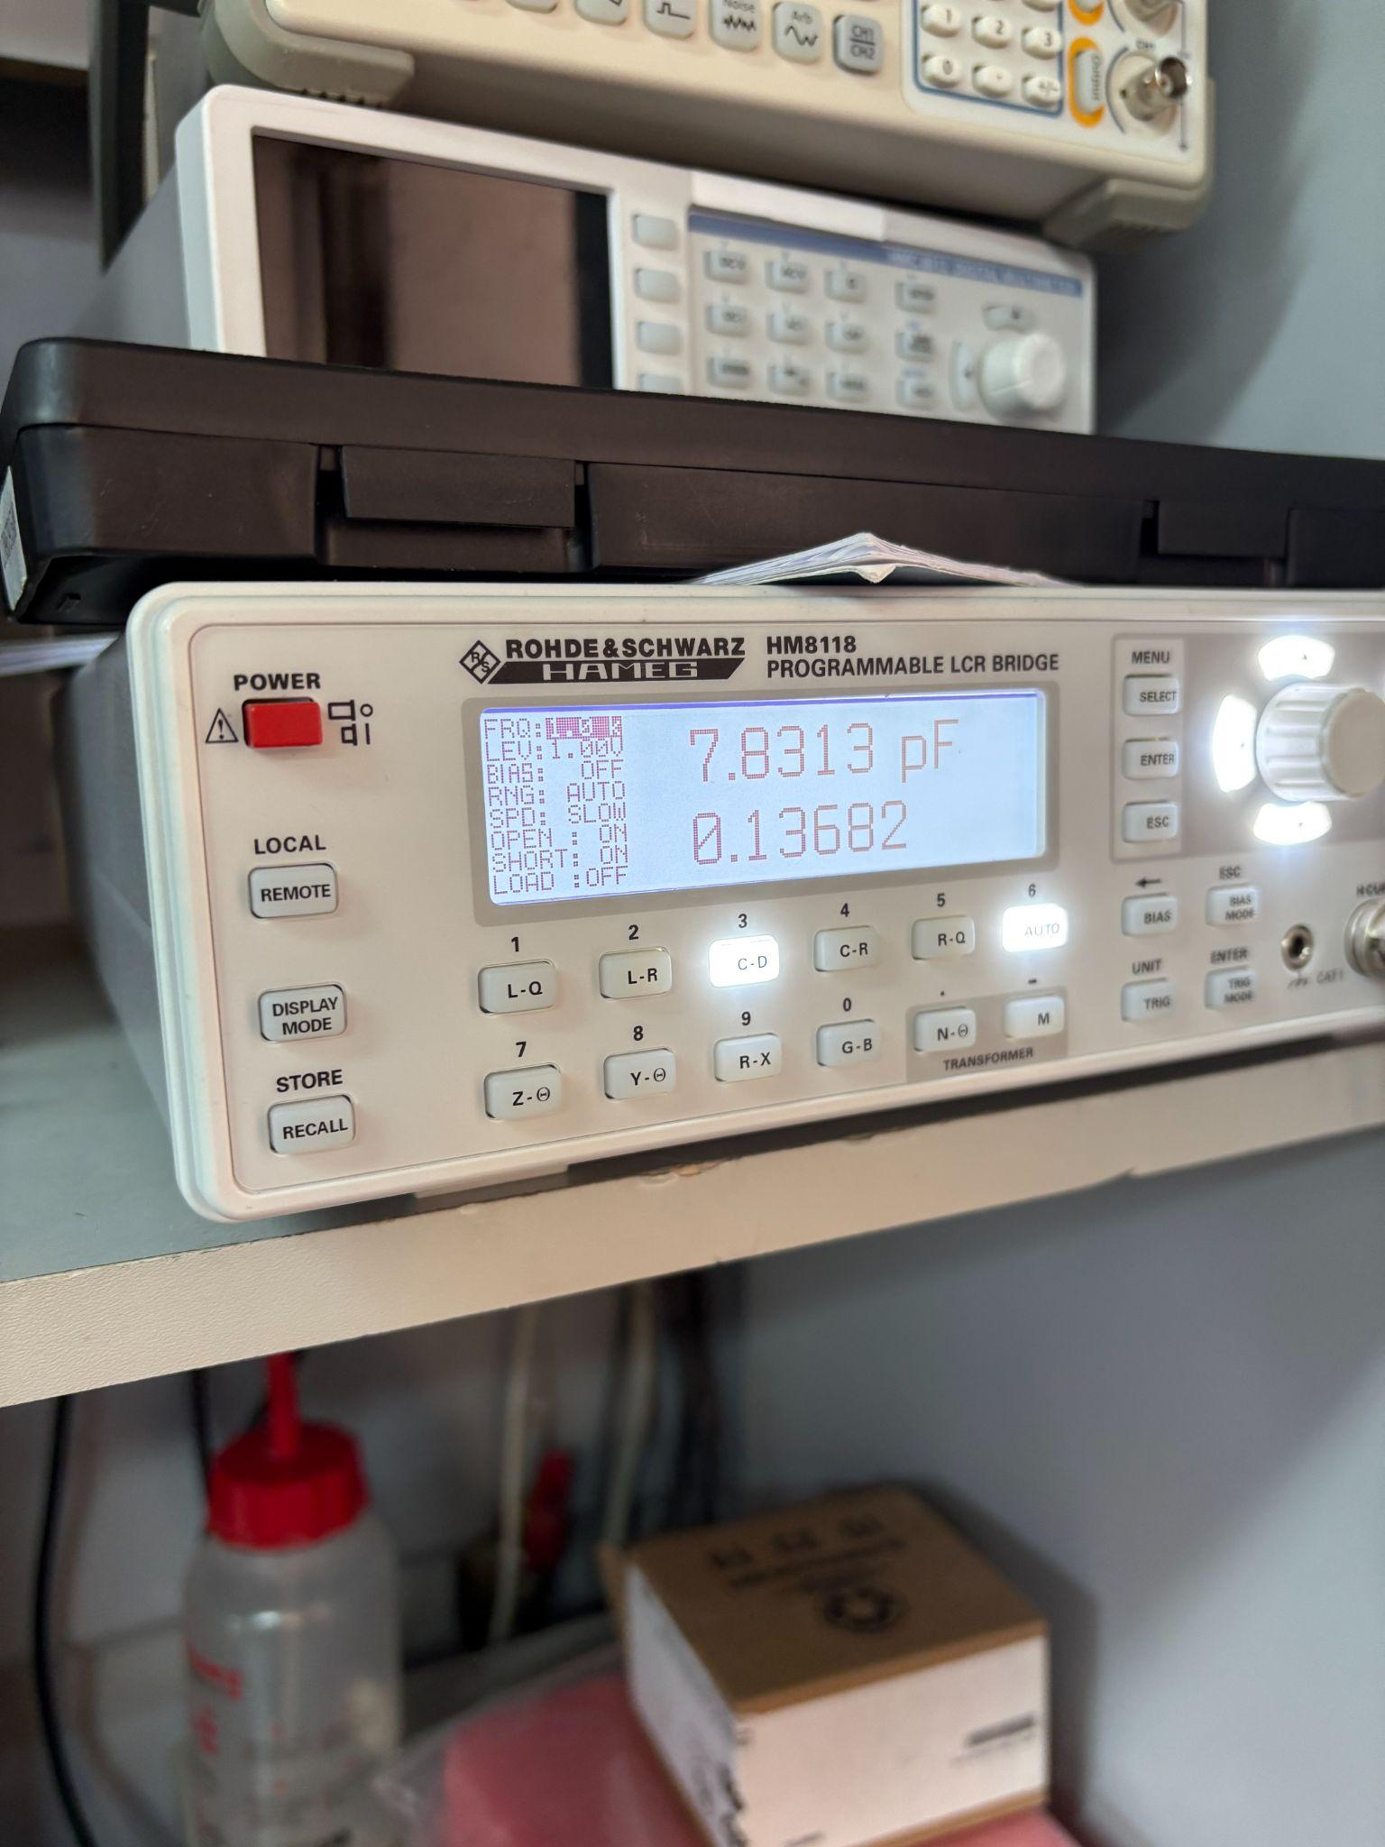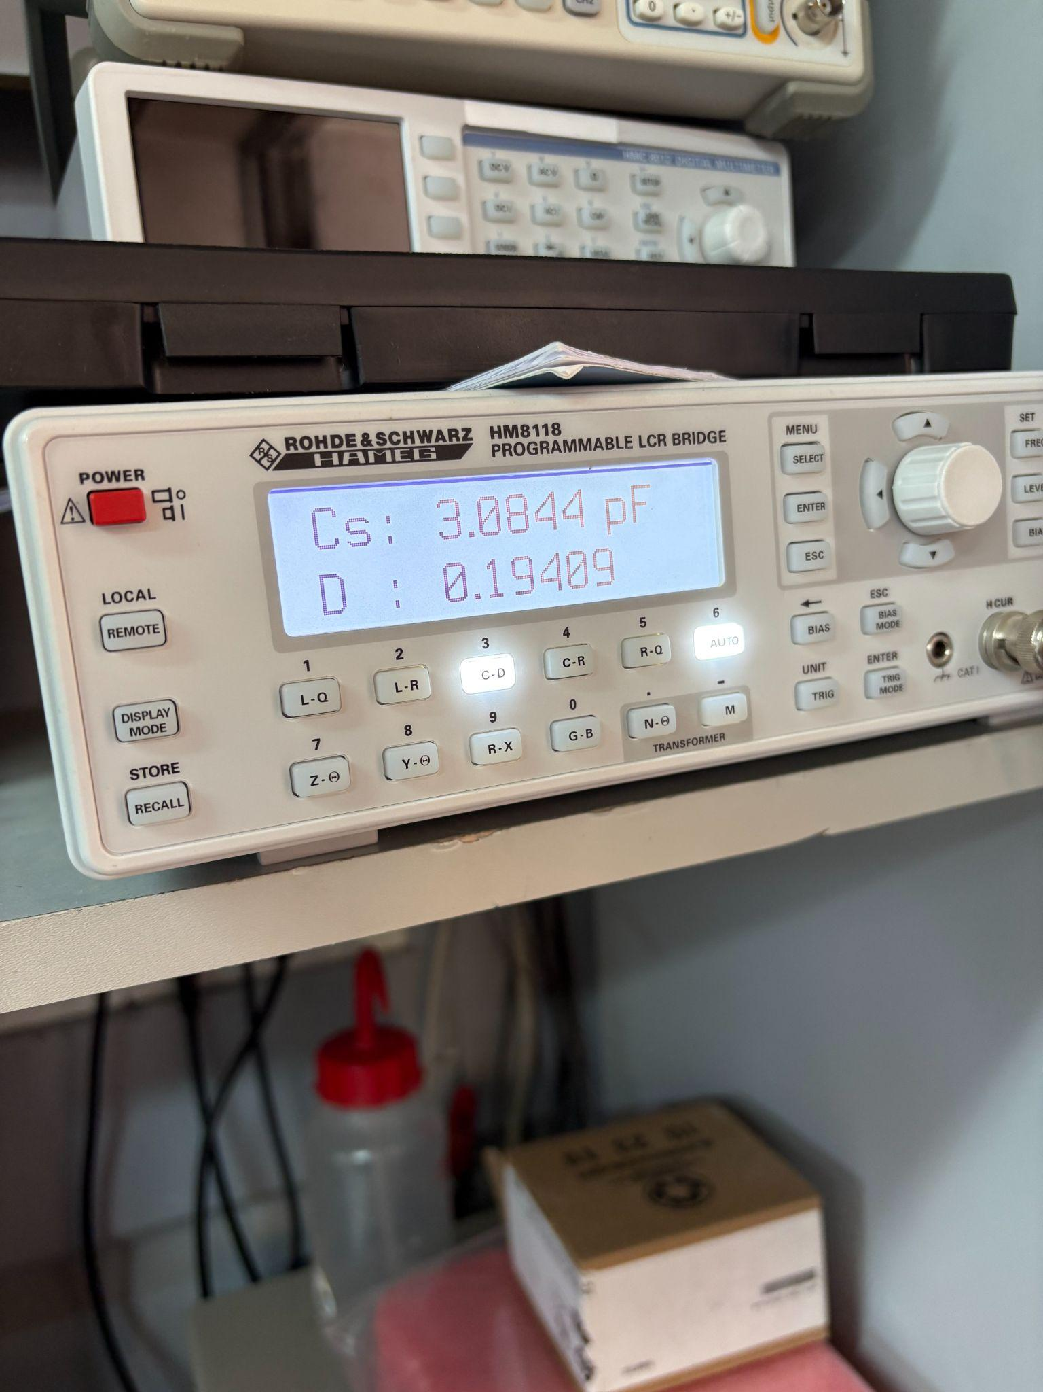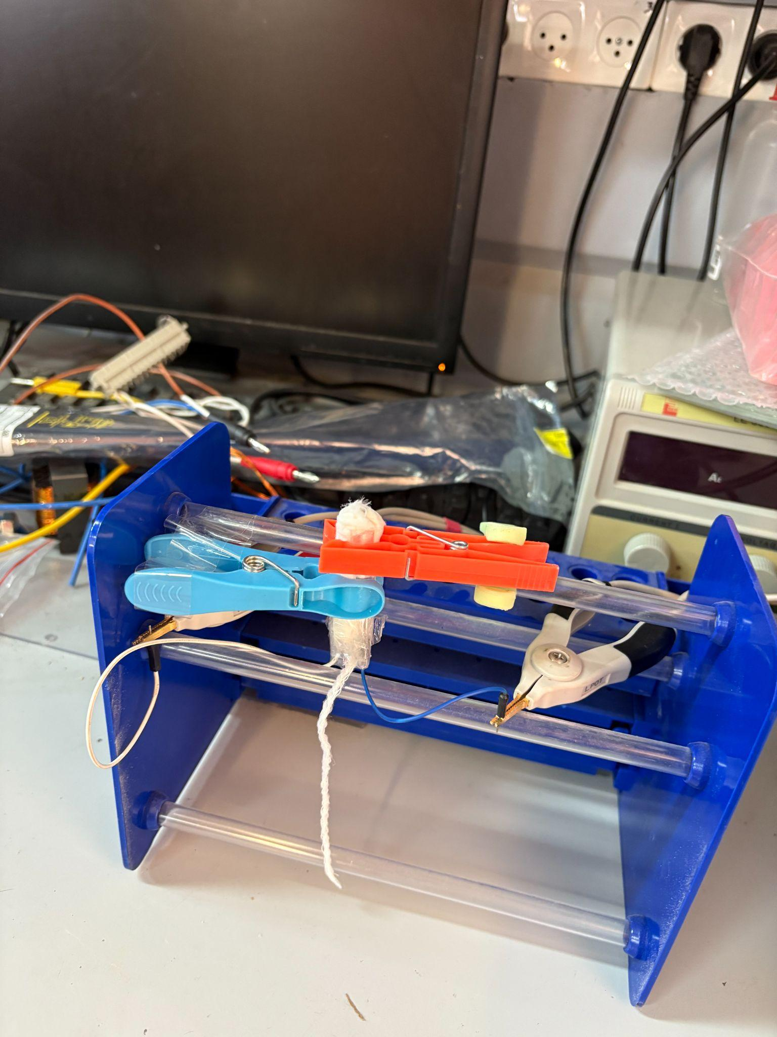

Experiment 2: Estimating Maximum Capacitance Under Simulated Conditions
Objective:
To determine the approximate maximum capacitance value of the sensor system when exposed to a fluid designed to mimic the electrical and absorption properties of menstrual blood.
Methodology:
A synthetic fluid was prepared using the following components:
- 100 mL of warm (non-boiling) water
- 0.9 g of table salt
- 30 mL of honey
- 0.2 g of cornstarch
- Red food coloring
To prevent direct fluid contact with the capacitive plates, the aluminum strips were insulated using multiple layers of electrical tape. The prepared tampon (with embedded capacitor) was inserted into a cut finger of a latex glove, with holes made on both ends to simulate limited fluid flow. A hair elastic was used to apply mild compression, simulating internal bodily pressure. The setup was positioned at an approximate 60° angle to imitate the orientation of a tampon inside the body.
Fluid was introduced dropwise using a syringe.
Results:
After administering approximately 10 mL of the synthetic fluid—aligned with our assumption of fluid uptake under suboptimal (in-body) conditions—leakage was observed from the tampon, indicating saturation. Capacitance readings stabilized at approximately 49–50 pF, consistent with prior estimations of maximum expected values.
